**Installation Guidelines and Setup for Firebase**

Firebase was used in smart vitals project as it provides real-time database, it is easier to get in sync with Flutter, additionally it provides authentication options as well.

Below are the step-by-step guidelines for the installation and setup for Firebase:

**Step 1:** Before beginning with the installation of firebase package, it is necessary to create project through firebase console.

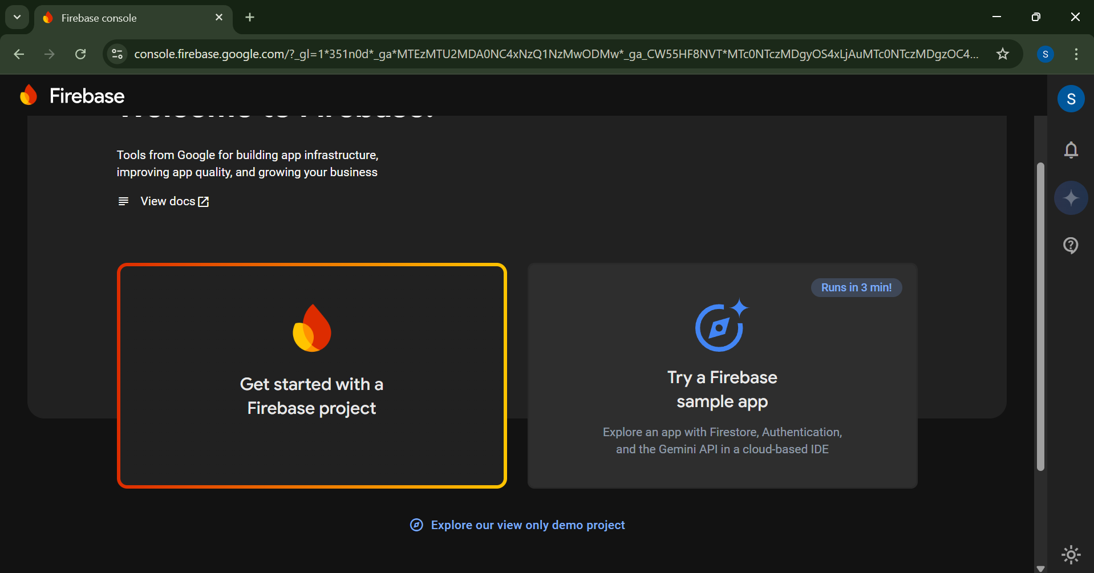

**Step 2:** Give an appropriate name for your project, and click on continue by agreeing to the terms and conditions.

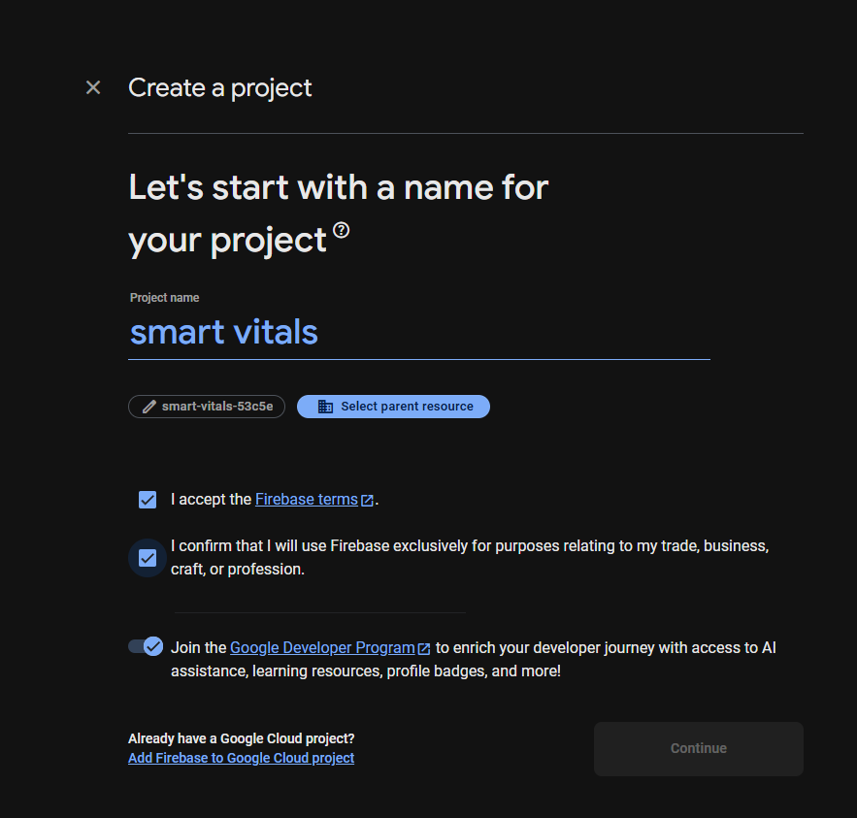 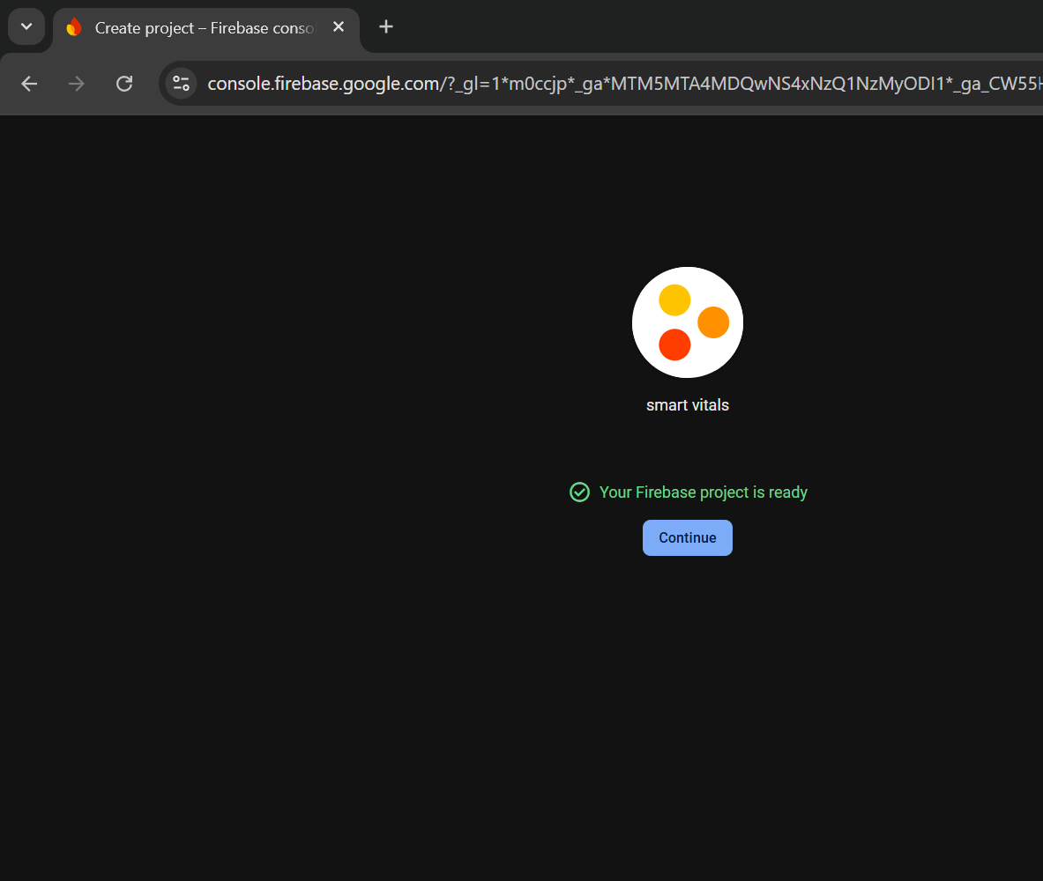

**Step3:** The created project can be seen in the firebase console.

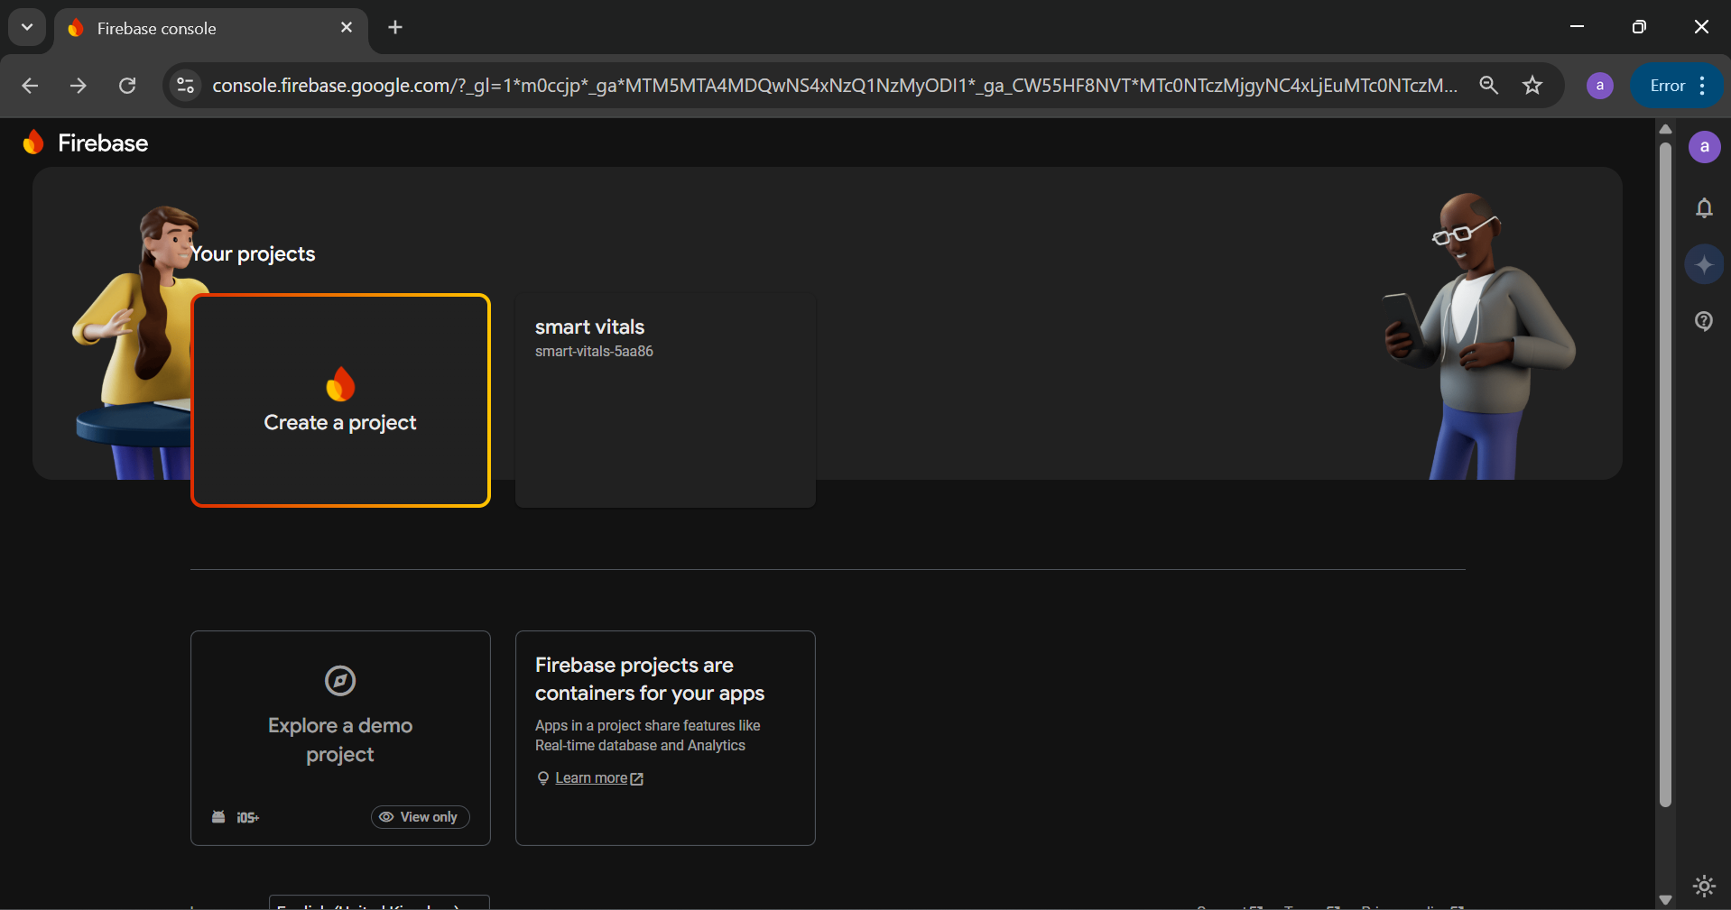

**Step 4:** Once the setup for the firebase console has been done, the installation process can begin.

Open cmd on your laptop, and enter “npm install firebase”, this command should install necessary firebase SDK packages.

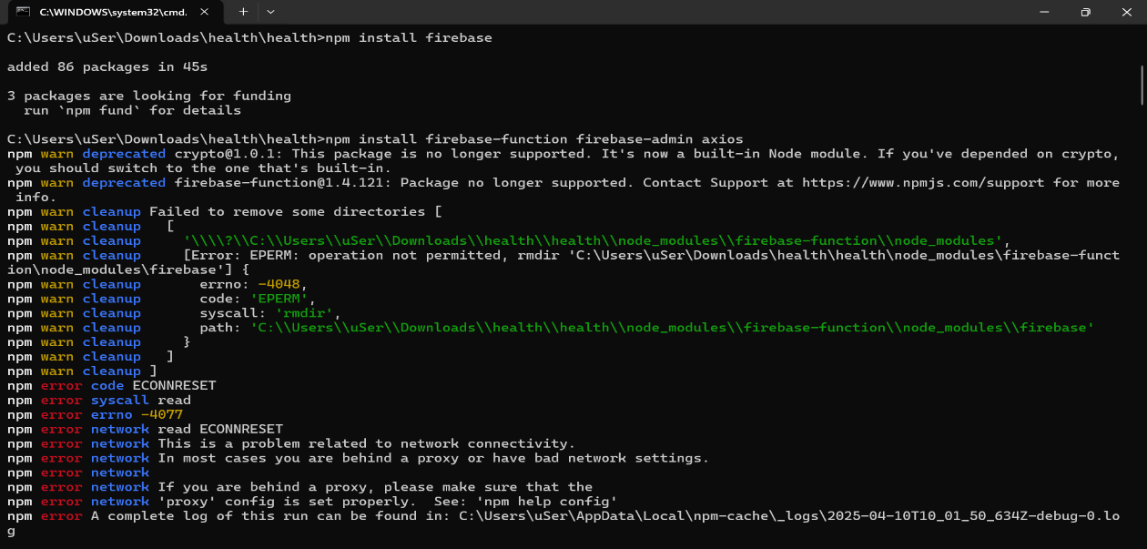

**Step 5:** Next enter “npm install -g firebase-tools” which installs Firebase CLI, which allows us to run global different commands.

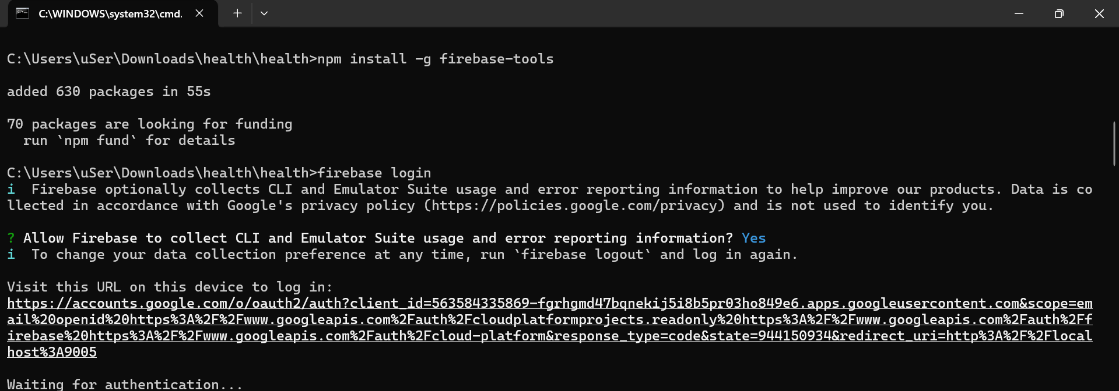

**Step 6:** The command firebase init allows to set up the project folder with the Firebase which allows the user to build, run and deploy the app.

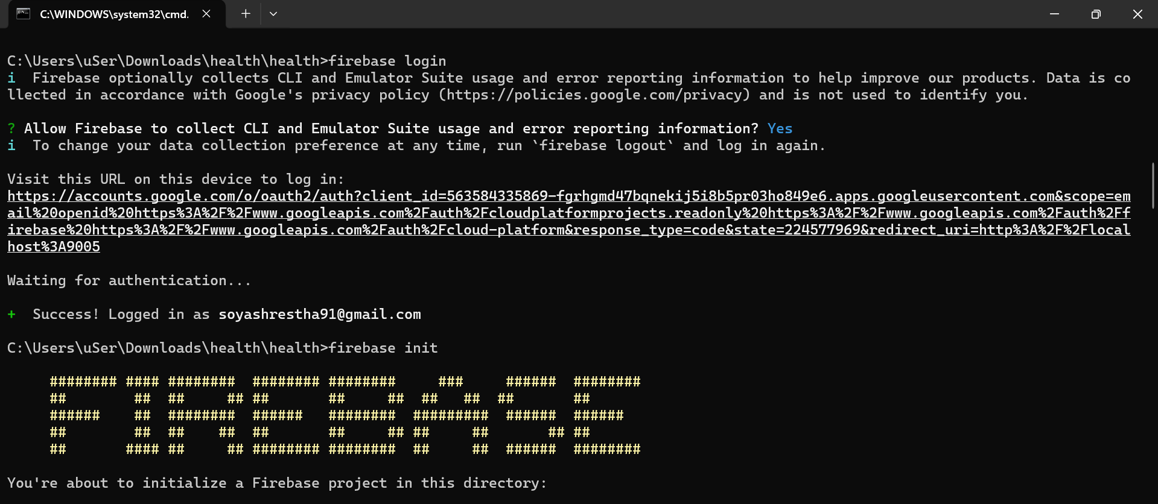

**Step 7:** Then, database schemas, was set up with data connection and then Dart SDK was created which enabled local building and evaluation.

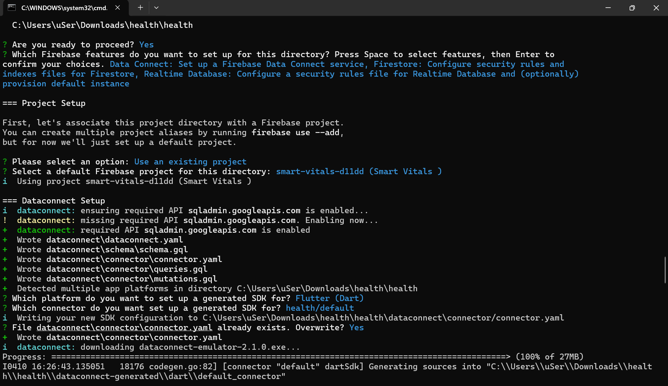

**Step 8:** After that, Firebase indexes and rules which allows API of Realtime Database, creating a new Realtime instance for Database and selecting the location for database instance.

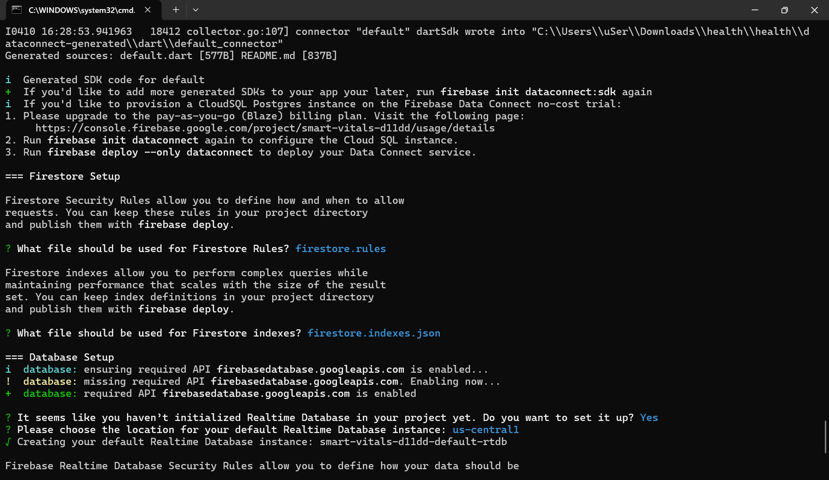

**Step 9:** Then the firebase setup was completed after selecting the file for security rules for Realtime Database.

